Nama : Eli Krisnawati

NIM :18090124

Kelas : 5B

**PRAKTIKUM 3**

1. Source Code

Matakuliah.php-> application/controller

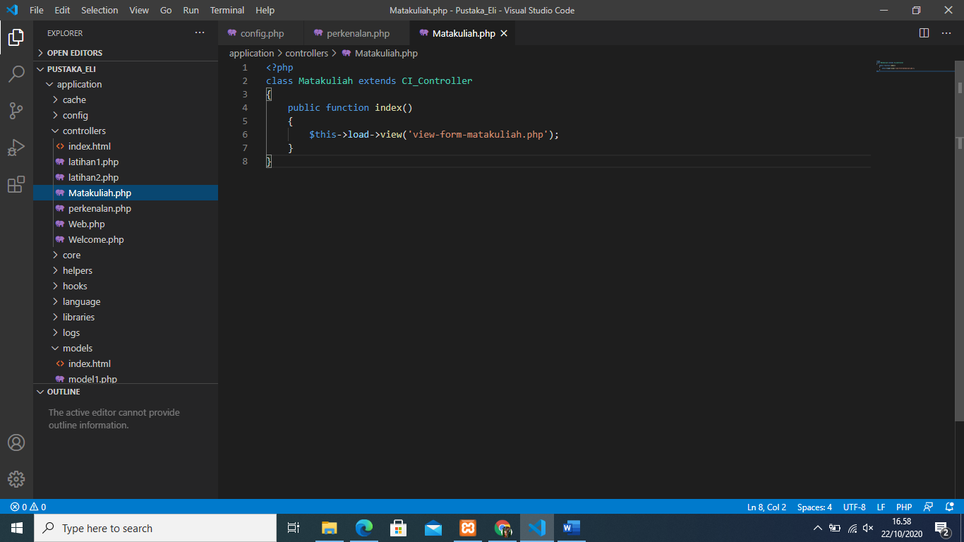

View-form-matakuliah.php->application/view

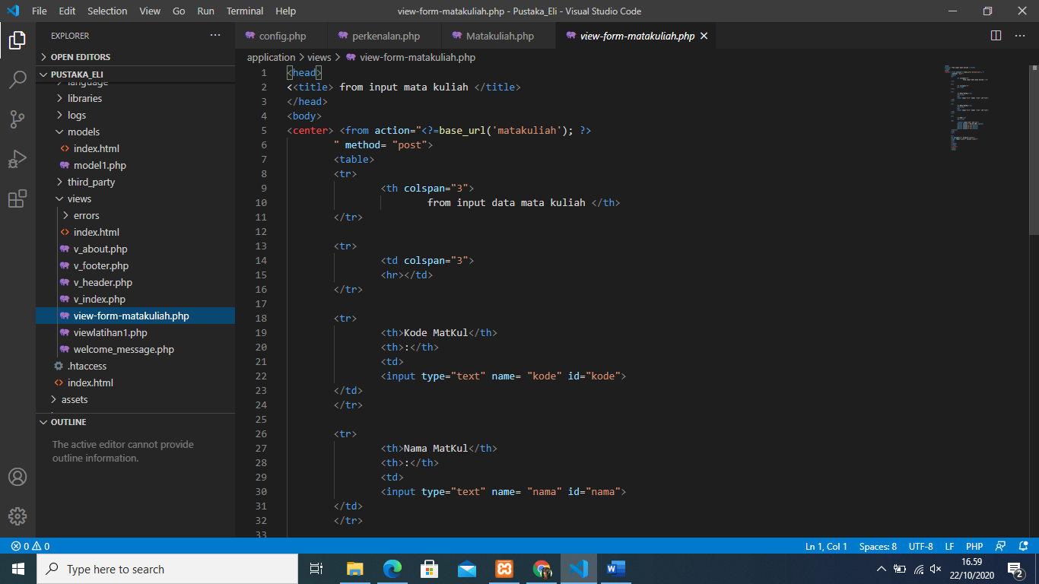

1. URL

<http://localhost/pustaka_eli/index.php/Matakuliah>

1. Capture Hasil

